THEORETICAL COMPETITION
January 17, 2012

Please read this first:

- The time available for the theoretical competition is 4 hours. There are three questions.
- Use only the pen provided.
- You can use your own calculator for numerical calculations. If you don’t have one, please ask for it from Olympiad organizers.
- You are provided with Writing sheet and additional paper. You can use the additional paper for drafts of your solutions but these papers will not be checked. Your final solutions which will be evaluated should be on the Writing sheets. Please use as little text as possible. You should mostly use equations, numbers, figures and plots.
- Use only the front side of Writing sheets. Write only inside the boxed area.
- Begin each question on a separate sheet of paper.
- Fill the boxes at the top of each sheet of paper with your country (Country), your student code (Student Code), the question number (Question Number), the progressive number of each sheet (Page Number), and the total number of Writing sheets used (Total Number of Pages). If you use some blank Writing sheets for notes that you do not wish to be evaluated, put a large X across the entire sheet and do not include it in your numbering.
- At the end of the exam, arrange all sheets for each problem in the following order:
- Used Writing sheets in order;
- The sheets you do not wish to be evaluated
- Unused sheets and the printed question.
Place the papers inside the envelope and leave everything on your desk. You are not allowed to take any paper out of the room.

Problem 1 (10 points)
This problem consists of three independent parts.

Problem 1.A. 2012 (4 points)

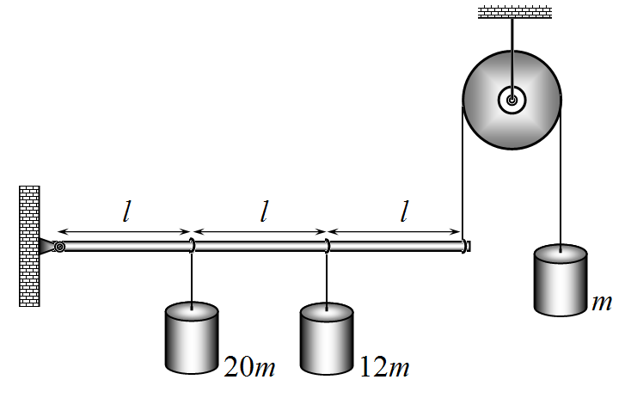
One end of a rigid weightless rod is fixed by a pivot. The weight of mass m is suspended to the other end of the rod with a thread which is thrown over the weightless block. Two more weights of masses 20m and 12m respectevily are hung by threads to the rod at the points that divide it into three equal parts (see the figure on the right). Assume all of the threads inextensible and weightless. Intitally, the rod is held in a horizontal position and then it is released. Find the accelerations of all of the weights immediately after the rod has been released. The acceleration of gravity is g.

Problem 1.B. Diodes ... (2.5 points)
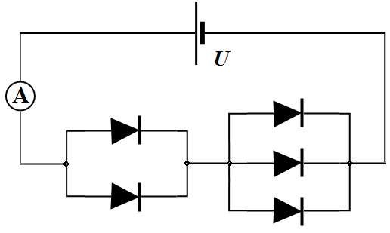
On a separate sheet of paper you are provided with the graph of the current-voltage characteristics of a diode (representing a current through a diode against its voltage drop, $I_{0}\left(U\right)$). Five identical diodes are connected in a circuit as shown in the figure on the right. Plot a graph of the current in the circuit against the voltage U of the source, when the latter varies from 0 to 3V.

Use a separate sheet of paper provided to plot the corresponding graph.
Do not forget to return it!

Problem 1.C. Flat lens (3.5 points)

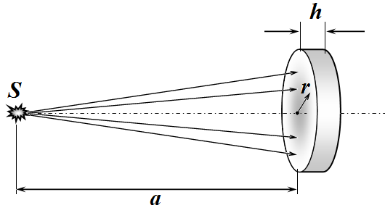
A round transparent plane-parallel disk of the thickness h is made of the material with the refractive index which depends on the distance r to the disk center according to the law
$n\left(r\right)=n_{0}\left(1−β r^{2}\right)$, (1)
where $n_{0}, β$ are known positive constants. The plate is surrounded by the air whose refractive index is n=1.
A point-like light source S is placed on the axis of the disk at the distance a () from its center. Show that the plate acts as some kind of a lens that forms a point-like image of the source. Determine the distance between the disk and the image of the source. What is the focal length of the lens?
Problem 2 (10 points)
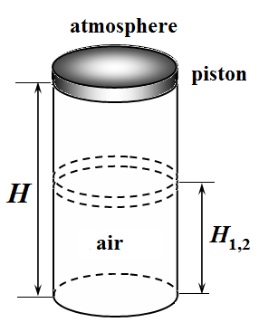
Adventures of a piston (10 points)
An open cylindrical vessel of the height cm and cross-sectional area cm² is filled with the air under the normal conditions, i.e. at the atmospheric pressure Pa and the temperature K. A thin heavy piston of mass kg is gently inserted into the vessel. The vessel wall and the piston are made of the material that conducts heat very poorly. Assume that air is an ideal diatomic gas with an average molar mass g/mol, the acceleration of gravity is m/s², and the universal gaseous constant is equal to J/(mol۰K). Heat capacities of the piston and the vessel, as well as the friction between the walls and the piston, are to be completely ignored.
The piston is released. The process of transition to final equilibrium consists of two consequitive stages. During the first stage the piston oscillates such that the corresponding gas processes cannot be considered quasistatic. Because of this, the piston oscillations are damped, that is the mechanical energy is dissipated. Assume that a half of the dissipated energy is transferred to the gas under the piston and the other half is given to the atmosphere. At this stage you can also neglect the thermal conductivities of the vessel and the piston. After the oscillations have vanished, the piston stops at some height .
The second stage appears to be quite slow, that is during some long period of time the piston achieves its final equilibrium position at some height .
2.1 [0.5 points] What is the air pressure in the vessel at the end of the first stage? Express your answer in terms of the atmospheric pressure , the adiabatic exponent and the parameter . Calculate the numerical value of .
2.2 [1.5 points] What is the temperature at the end of the first stage? Express your answer in terms of , and . Calculate the numerical value of .
2.3 [0.5 points] Find the height . Express your answer in terms of , and . Calculate the numerical value of .
2.4 [0.5 points] What is the air pressure in the vessel at the end of the second stage? Express your answer in terms of and . Calculate the numerical value of .
2.5 [0.5 points] What is the temperature at the end of the second stage?
2.6 [0.5 points] Find the height . Express your answer in terms of and . Calculate the numerical value of .
2.7 [2 points] Find the frequency of small oscillations around the equilibrium position of the piston, assuming that the process is quasistatic and adiabatic. Express your answer in terms of , , and . Calculate numerical value of .

At the end of the second stage, a great number of small holes are made in the bottom of the vessel whose total cross-sectional area is cm². The size of each hole is much smaller than the mean free flight path of air molecules. After some time the piston starts to move with the constant velocity u.
It is known that the average number of molecules hitting the unit of surface area per unit of time is equal to
$\bar{N}=\frac{1}{4}n\bar{v}$, (1)
where is the so-called average thermal velocity of molecules, and stands for the number density.
The average kinetic energy of translational motion of molecules passing through the holes is
, (2)
where is the Boltzmann constant.
Assuming that the heat flow through the walls of the vessel and the piston is completely negligible, answer the following questions:
2.8 [1 point] The steady air pressure under the piston has the form , where A is a constant that depends on , while is a function of . Find A and . Calculate the numerical value of .
2.9 [2 points] The steady velocity of the piston has the from , where B is a constant depending on , , , and , while is a function of . Find B and . Calculate the numerical value of u.
2.10 [1 point] The steady temperature of the gas under the piston has the form , where C is a constant that depends on , while is a function of . Find C and . Calculate the numerical value of .

Problem 3
Nuclear droplet (10 points)

In this problem you have to investigate basic characteristics and stability conditions of atomic nuclei. Let an atomic nucleus contain A nucleons (A is the atomic weight of the corresponding element), namely, Z protons (Z is the atomic number in the table of chemical elements) and neutrons. The expression for the total energy of the nucleus can be written as
, (1)
where denotes the nucleus mass, is the mass of the free proton, is the mass of the free neutron, stands for the speed of light, and is the interaction potential energy of the nucleons in the nucleus.
The interaction potential energy of the nucleons can be described by the following semi-empirical formula proposed by Weizsäcker
, (2)
where MeV, MeV, MeV, MeV.
Weizsacker semiempirical formula corresponds to one of the simplest model of the atomic nucleus, the so-called spherical liquid droplet model, which relies on the analogy between a nucleus and a droplet of an ordinary liquid. The mass and the charge of a nucleus is assumed to be uniformly distributed inside a sphere of some radius, and the nucleon fluid is characterized by some parameter which is an analogue of the surface tension of the liquid.
The formula for the potential energy takes into account the following contributions:
- surface energy, which takes into account the surface tension of the nuclear matter in the liquid droplet model;
- the energy of the Coulomb repulsion of the protons within the nucleus;
- the exchange interaction energy reflecting the trend towards the stability of nuclei at N=Z;
- direct dependence on the number of nucleons A due to nuclear forces.
At the derivation of his semiempirical formula Weizsäcker used an experimentally established fact that the following dependence holds for nucleus radius on the number of nucleons
, (3)
where is a constant.
Starting from the above statements, find answers to the following questions:
3.1 [2 points] Find the electrostatic energy of a ball of radius R, uniformly charged with the net charge Q. Express your answer in terms of the charge Q, the dielectric constant and the radius R of the ball.
3.2 [1 point] Find the formula and the numerical value of the coefficient in formula (3).
3.3 [1 point] Find the formula and the numerical value of the density of the nuclear matter.
3.4 [1 point] Find the formula and the numerical value of the surface tension of the nucleon liquid.
Suppose now that the nucleus fisses (is divided) into two fragments with atomic weights kA and (1-k)A respectively, where 0<k<1. Assume that the electric charge and the number of neutrons are distributed between the fragments similar to the atomic weight.
3.5 [2 points] Nuclear fission (division into fragments) becomes energetically favorable under the condition . Find an expression for the function and plot its graph schematically.
3.6 [0.5 points] Find the limiting value at which the spontaneous fission is still theoretically possible.
Under the above condition in 3.5, a nucleus can stay stable for quite a long time. For example, the half-life of Uranium-235 nucleus is equal to 713 million years. Consequently, an instantaneous fission is prevented by an energy barrier, which disappears at some critical value . In fact, a nucleus will only fiss if a significant deviation of its shape from the ball occurs.
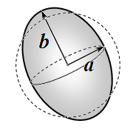
For the sake of simplicity assume that a spherical nucleus undergoes such a deformation that its surface turns into a prolate ellipsoid of rotation, which is described in the Cartesian coordinates by the equation
, (4)
where a is a minor, and b is a major semi-axes of the ellipsoid, respectively.
The volume of a prolate ellipsoid is given by
, (5)
and its surface area can be calculated via the formula
. (6)
Let a spherical nucleus undergo such a deformation that and , so that $ε, λ\text{<<}1$, and R is the initial radius of the nuclear droplet.
3.7 [0.5 points] Find the relation between and .
Calculations show that the energy of the electrostatic interaction of protons of the deformed nucleus is equal to $E_{C}^{\text{deformed}}=E_{C}\left(1−\frac{1}{6}ε\left(ε+λ\right)\right)$.
3.8 [2 points] Find the expression and calculate the numerical value of .

Known physical constants
Elementary charge C
The dielectric constant F/m
The mass of the nucleon (proton or neutron) kg
1еVVJ

In solving these problems you can use the following formulae:
, at $\left|x\right|\text{<<}1$,
${\left(1+x\right)}^{α}≈1+αx+\frac{α\left(α−1\right)}{2}x^{2}$, at $\left|x\right|\text{<<}1$.

